Writing 1 Benchmark Assessment October Name: _____________________________
Part 1: Use these verbs correctly to complete the sentences below. Change the verb tense.
be have dial go
call see tell arrive
1. Last night, John ____________ very tired when he _____________ to bed.
2. He ________________ chest pains right now.
3 3. John ________ never _________ chest pains before.
4. Someone should __________ 911. 5. His neighbor, Sam, __________ him and ___________ 911.
6. The 911 operator ____________ Sam to stay on the line.
7. The operator tells Sam that the paramedics ______________________ soon.
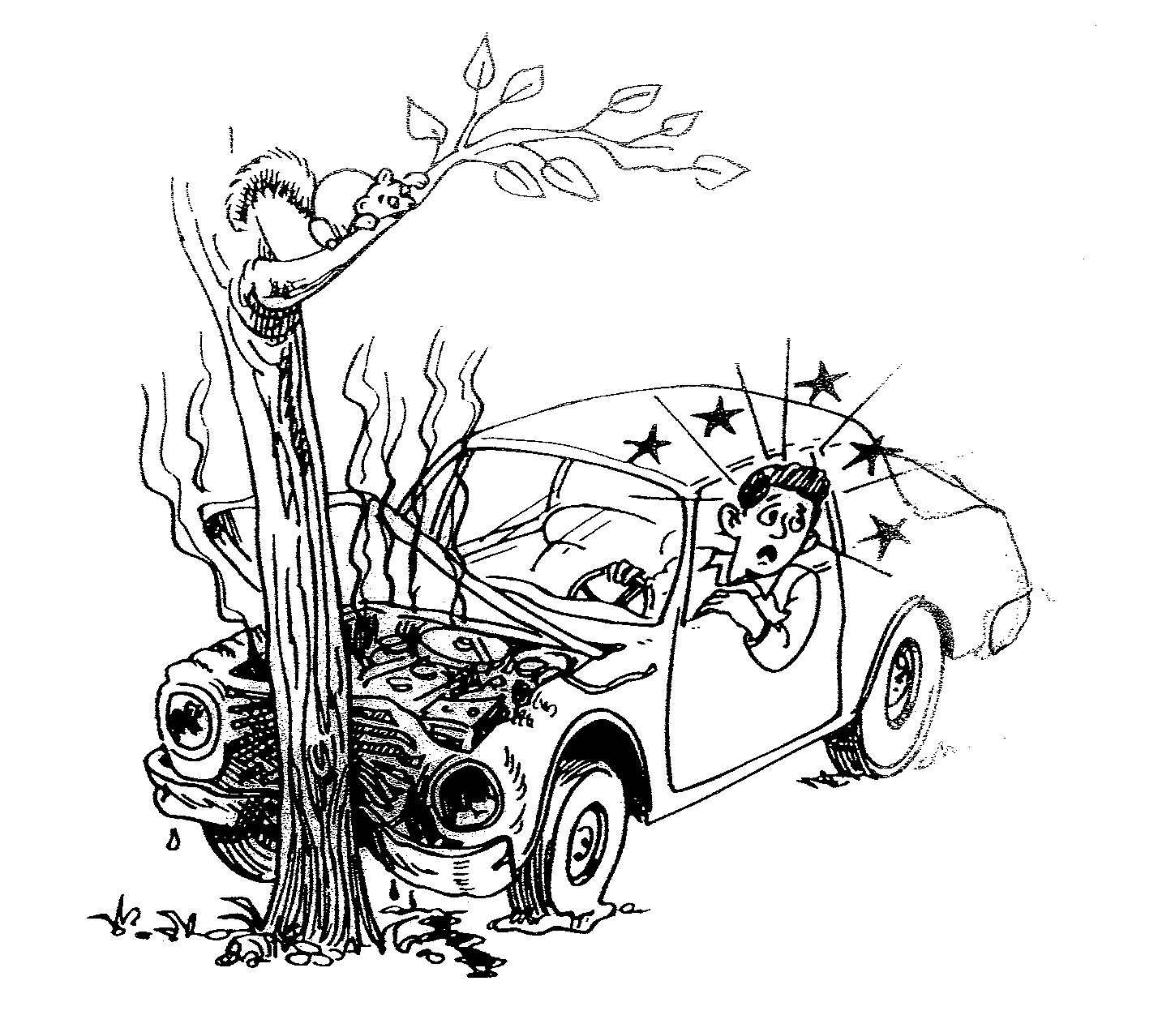
Part 2: Answer the questions with complete sentences and correct verb tenses.
8. What just happened to Vue?
Vue
______________________________________
______________________________________
9. How does Vue feel?
______________________________________
______________________________________
10. What will happen next?
____________________________________________________________________________

11. If you witnessed this accident, and called 911, what would you tell the operator?
___________________________________________________________________________________
12. Have you ever been in a car accident? _________________________________________________

Part 3: Cross out and change all the present tense verbs in this story to the past tense.
Sam needs to leave work. He feels sick, and he can't concentrate on his work. He thinks he has a fever, and he doesn't want to make his co-workers sick, too. Sam goes home, takes some aspirin, drinks some tea and rests in bed. He hopes he won’t miss much work.

