October Writing 1 Practice Assessment
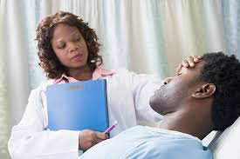
Part 1: Use the picture above to complete the sentences.
have surgery visit 15 patients be go home rest work at feel better
1. Right now this man __________________________ in a hospital bed.

2. Dr. Ross __________________________________________________________ yesterday.

3. Hopefully, this man ________________________________________________ tomorrow.

4. Last night this patient _______________________________________________.

5. Dr. Ross _______________________ Regions Hospital five days a week.

6. Dr. Ross __________________ an excellent physician.

7. The patient _____________________________________ in two days.

Part 2: Change all the verbs in this story to the past tense.
Madge (is) ______ a single mom. She (has) ______ three children. She (raises) __________ them by herself. Plus, Madge (works) ____________ full time. She (is) ________ busy and tired. She (has) _______ headaches. She (works) ______________ long hours. Her job (is) _______ hard. After work, Madge (cooks) ____________ dinner. Then she (cleans) ____________ the kitchen. Her kids (need) ______________ help with homework, so she (helps) _____________ them.
Madge (reads) __________ them a short book. She (tucks) _____________ them into bed. Then Madge (calls) _____________ her friend Paige. “I am stressed out. What can I do?” Madge (asks) ____________. Paige (says) _________, “Take a short walk. Try daily exercise. This will make you less tired. Eating less junk food will help too.”
Part 3: Read the paragraph below, then answer the questions with a complete sentence.
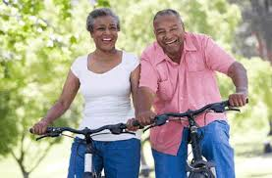
Ann and Jim are older and retired, but they both like to be active. Mainly, they exercise to stay healthy, but they also think it's fun to do a variety of activities together. Every morning they walk outside for 30 minutes after they eat breakfast. They also like to ride their bikes in the afternoon if the weather is nice. Two days ago, they biked six miles along a beautiful bike trail at their favorite park, and tomorrow they will take a dance class at a recreation center near their home. They always make sure to drink a lot of water when they’re done. As you can see in this picture, Ann and Jim really enjoy exercising outside together.

1. What are Ann and Jim doing in this photo?

__________________________________________________________________________
2. Does Ann ride her bike when it rains?

__________________________________________________________________________
3. What did Ann and Jim do after they ate breakfast yesterday?

__________________________________________________________________________
4. What will Ann and Jim do at a recreation center tomorrow?

____________________________________________________________________________
5. What do they always make sure to do?

6. What do you like to do to stay active?

_____________________________________________________________________________
7. Do you think they have a good relationship or not? Why or why not?

_____________________________________________________________________________

_____________________________________________________________________________

