Neither and nor examples:
Rule: Use ‘neither’ and ‘nor’ for most sentences. Ex: My father neither smokes nor drinks.
You must use a negative verb if you only use ‘nor.’ Ex: He can't see nor hear.
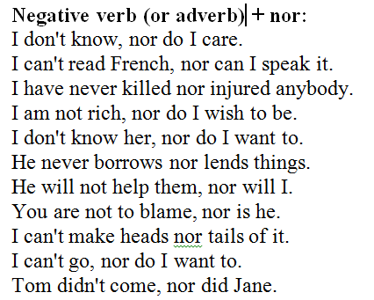
Neither + nor:
I have neither time nor money for that.
Neither Tom nor Mary was in a good mood.
I neither drink nor smoke.
It's neither good nor bad.
He can neither read nor write.
I have neither time nor money.
She's neither rich nor famous.
Neither Mary nor John can swim.
He is neither handsome nor ugly.
He neither wrote nor called.
I like neither apples nor grapes.
I neither heard nor saw anything.
I can speak neither French nor German.
My son can neither read nor write yet.
He likes neither baseball nor football.
Neither happiness nor sadness can last forever.

Neither and nor examples:
Rule: Use ‘neither’ and ‘nor’ for most sentences. Ex: My father neither smokes nor drinks.
You must use a negative verb if you only use ‘nor.’ Ex: He can't see nor hear.
Neither + nor:
I have neither time nor money for that.
Neither Tom nor Mary was in a good mood.
I neither drink nor smoke.
It's neither good nor bad.
He can neither read nor write.
I have neither time nor money.
She's neither rich nor famous.
Neither Mary nor John can swim.
He is neither handsome nor ugly.
He neither wrote nor called.
I like neither apples nor grapes.
I neither heard nor saw anything.
I can speak neither French nor German.
My son can neither read nor write yet.
He likes neither baseball nor football.
Neither happiness nor sadness can last forever.

