How I Got My Scar
Do you see this scar on my left hand? Let me tell you how it happened. When I was 23, I had a car accident. It was raining heavily, and I had to stop quickly at a red light, but my car slipped on the wet road. I lost control of my car, and it went off the road and smashed into a large tree. I cut my face and broke a bone in my left hand. Someone called 911, and an ambulance arrived in about 15 minutes. The paramedics took me to the hospital emergency room. The emergency room doctors stitched the cut on my face, and they had to do surgery to put a metal pin in my hand because the bone was fractured so badly. The pin held my bone together so it could heal. A couple months later, the doctor removed the pin. Because of that accident and the surgery, I now have this large scar on my hand. Here’s a picture from after the surgery.

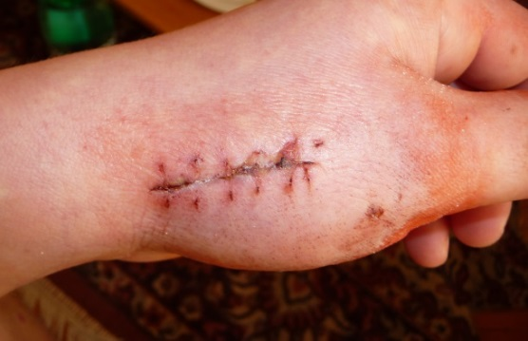
- What serious thing happened to the writer?
________________________________________________
________________________________________________
- Why did it happen?
_____________________________________________________________________________
- What injuries did the writer have?
_____________________________________________________________________________
- How did the doctors treat the writer?
_____________________________________________________________________________
- Why does the writer have a scar?
_____________________________________________________________________________
6. Do you have any scars? If so, how old were you when you got the injury?
____________________________________________________________________________

