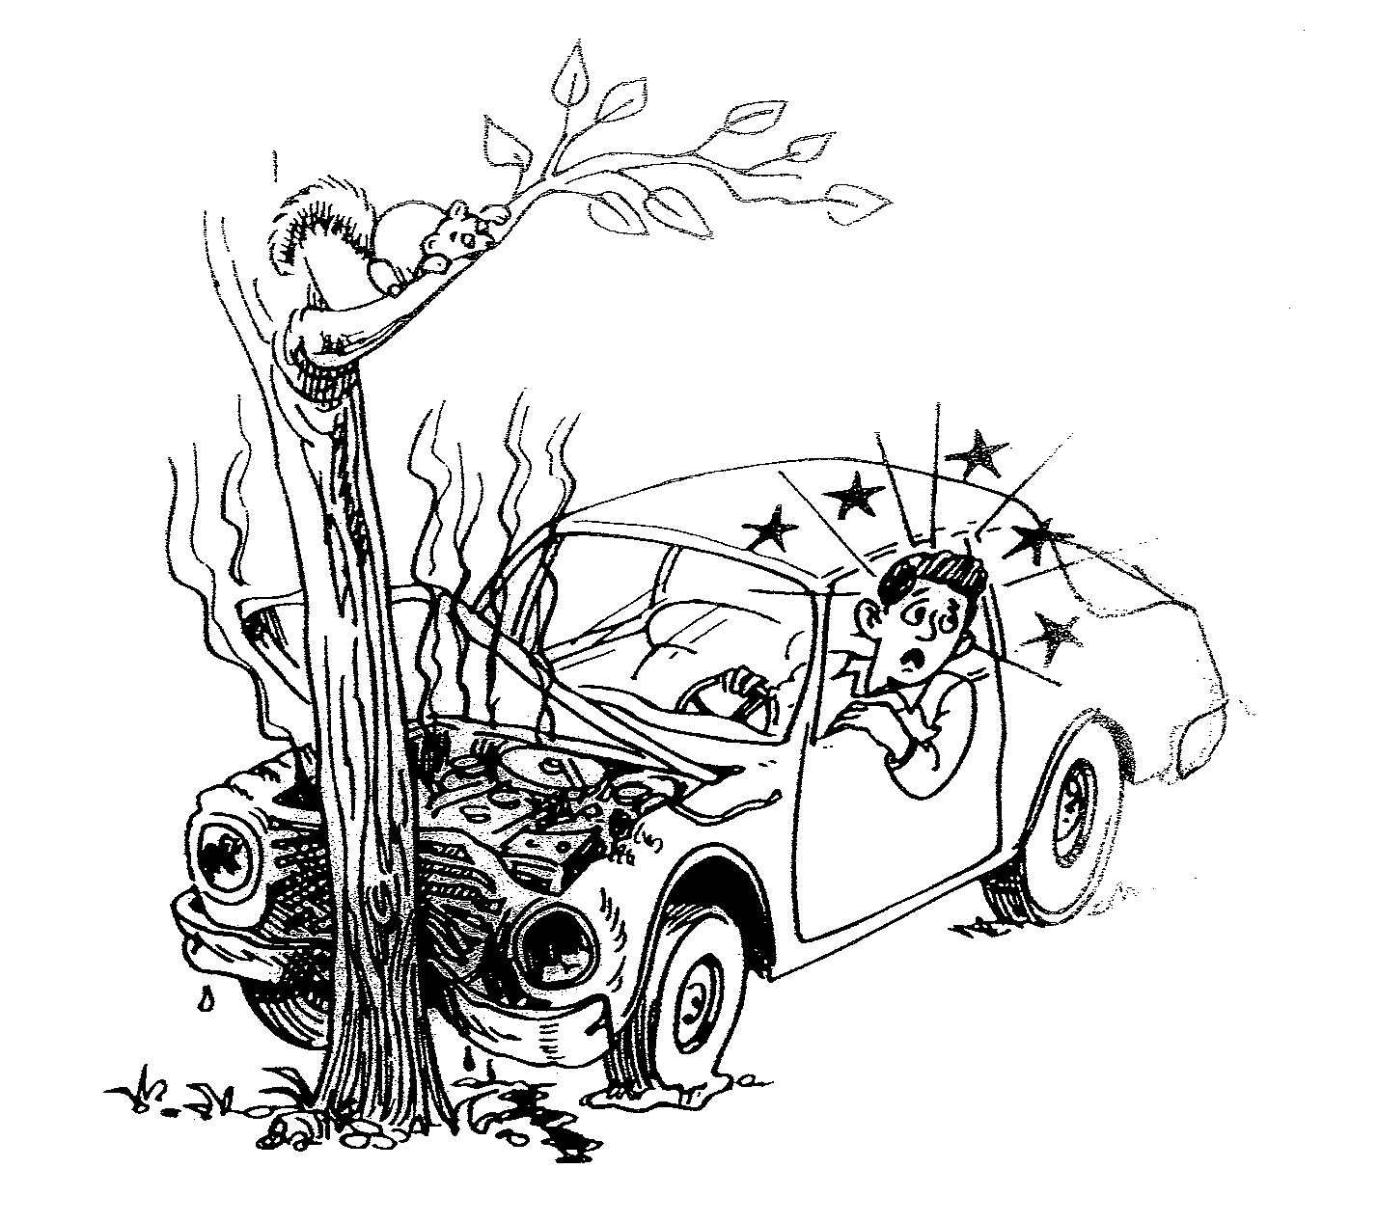
What happened? How does he feel? What is happening? What do you see? What will happen next? Write as much as you can for 15-20 minutes.

