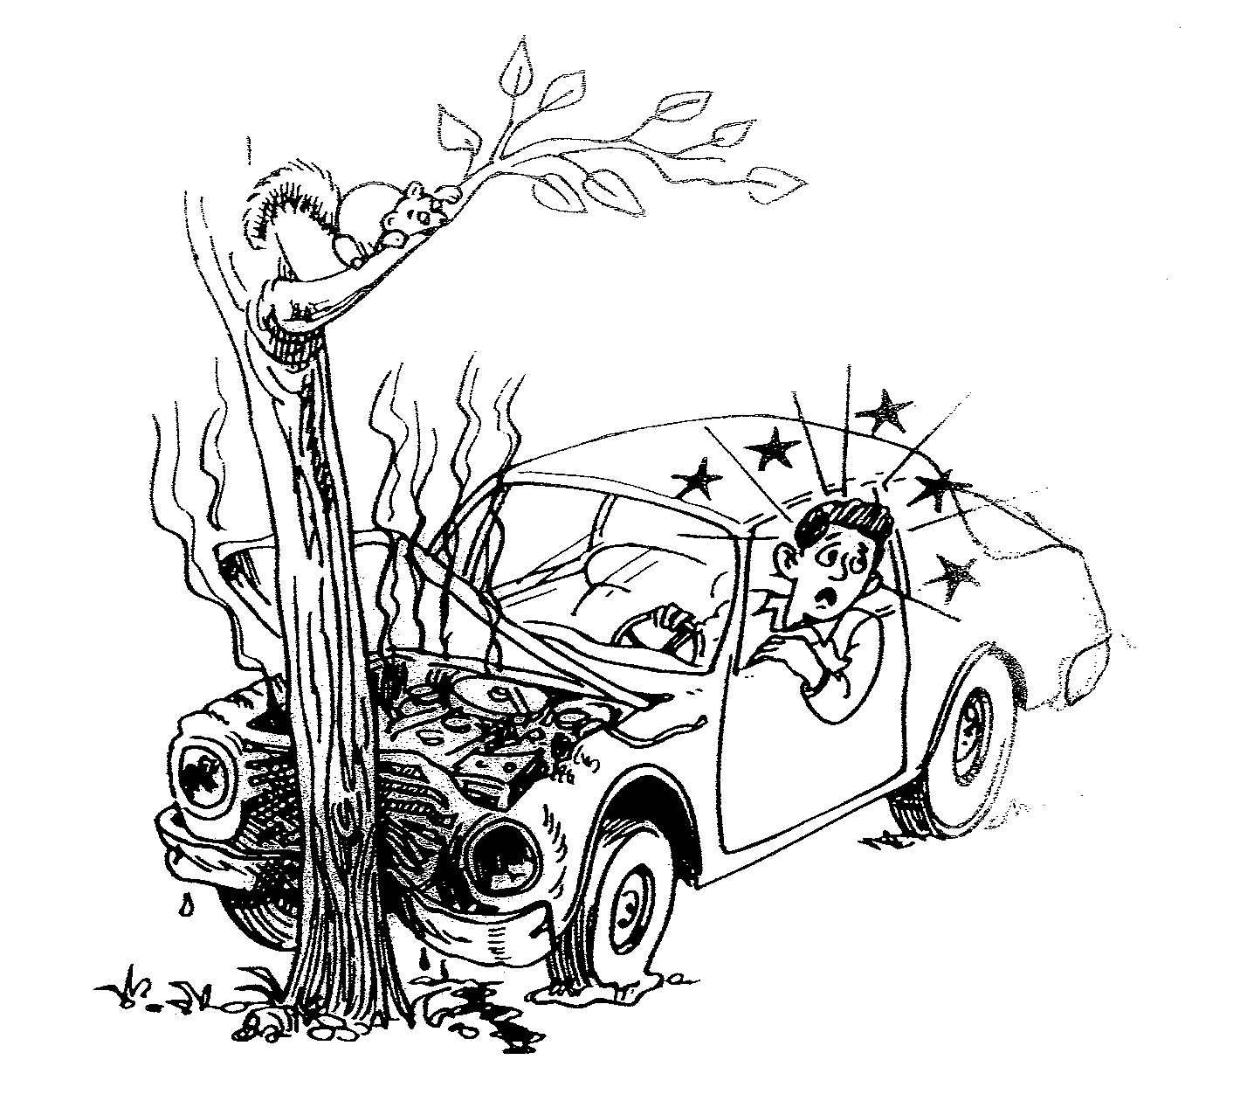
Correct these sentences.
1. He is hit a tree.

2. I think he had injured.

3. He will happened someone call 911.

4. The man got car accident.

5. He looks having leg broken.

6. The car will be fire.

7. He will waiting someone helping him.

8. The car is smoke and flat tire.

9. He fell dizzy and hurted.

10. A man drivered his car and hitted a tree.

