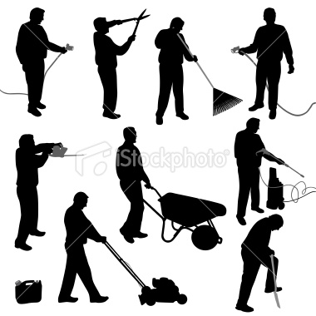
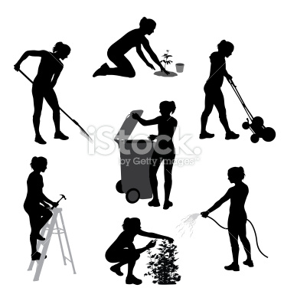
13
12
11
4
2
1

3

14

7
6
5

16

15
10
8
9

Yard Work (What are they doing?)
1.
2.
3.
4.
5.
6.
7.
8.
9.
10.
11.
12.
13.
14.
15.
16.

