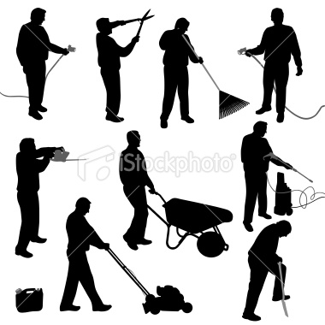

Write 5 sentences about the yard work they are doing.
1.____________________________________________________________________
2. _________________________________
___________________________________
3. _________________________________
___________________________________
4. _________________________________
___________________________________
5. _________________________________
___________________________________

Write 5 sentences about the yard work they are doing.
1.____________________________________________________________________
2. _________________________________
___________________________________
3. _________________________________
___________________________________
4. _________________________________
___________________________________
5. _________________________________
___________________________________

Write 5 sentences about the yard work they are doing.
1.____________________________________________________________________
2. _________________________________
___________________________________
3. _________________________________
___________________________________
4. _________________________________
___________________________________
5. _________________________________
___________________________________

