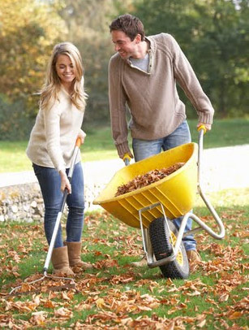
Use these verbs in the sentences.
Remember to change the verb tense.
rake be forget work push
put decide dump wear get

1. It ______ Saturday today.
2. Last night Lisa and Tim ________________ to do some yard work.
3. Earlier this morning, they _____________ on some old clothes and _____________ the tools out of their garage.
Lisa and Tim
4. They are _____________ outside in their yard.
5. Lisa _________________ leaves, and Tim __________________ a wheelbarrow right now.
7. In a couple minutes, it ___________ full, and he ________________ the leaves in a big pile.
8. Tim usually ____________ work gloves, but he ____________ to buy some yesterday.

Use these verbs in the sentences.
Remember to change the verb tense.
rake be forget work push
put decide dump wear get

1. It ______ Saturday today.
2. Last night Lisa and Tim ________________ to do some yard work.
3. Earlier this morning, they _____________ on some old clothes and _____________ the tools out of their garage.
Lisa and Tim
4. They are _____________ outside in their yard.
5. Lisa is ________________ leaves, and Tim is ________________ a wheelbarrow right now.
7. In a couple minutes, it ___________ full, and he ________________ the leaves in a big pile.
8. Tim usually ____________ work gloves, but he ____________ to buy some yesterday.

