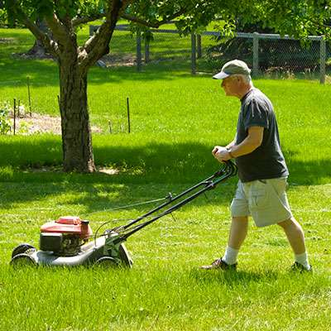
Yard Work Quiz
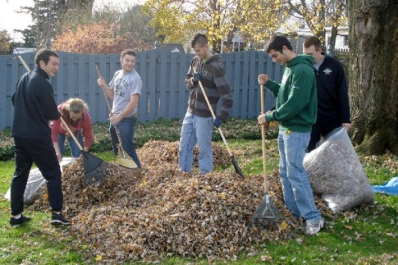

1. What are they doing?
__________________________________________________________
____________________________________________________________________________________________________________________
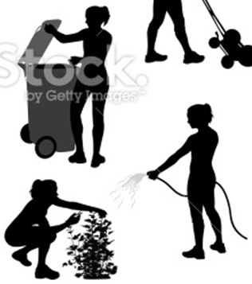
2. What are these women doing?
__________________________________
__________________________________
__________________________________
__________________________________
__________________________________
__________________________________
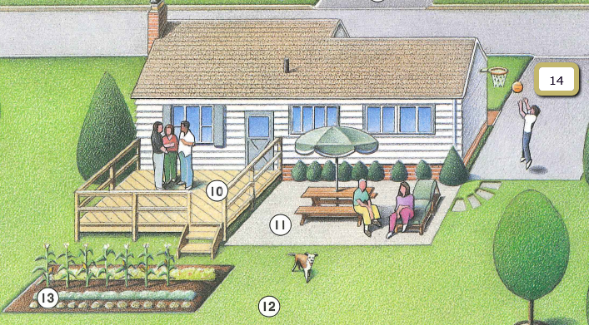
3.

10. 11. 12.
13. 14.
Yard Work Quiz
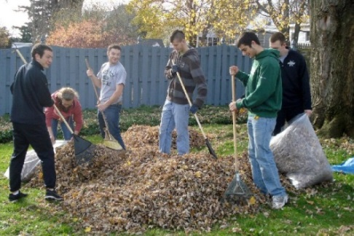

1. What are they doing?
__________________________________________________________
____________________________________________________________________________________________________________________
2. What are these women doing?
__________________________________
__________________________________
__________________________________
__________________________________
__________________________________
__________________________________
3.

10. 11. 12.
13. 14.

