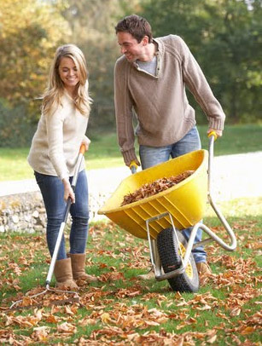
Writing 1 April Benchmark Assessment
Name: ______________________________
Part 1: Use these verbs in the sentences.
Remember to change the verb tense.
rake be forget work push
put decide dump wear get

1. It _______ Saturday today.
2. Last night Lisa and Tim ________________ to do some yard work.
3. Earlier this morning, they ____________ on some old clothes and _____________ the tools out of their garage.
Lisa and Tim
4. They are ______________ outside in their yard.
5. Lisa _________________ leaves, and Tim ___________________ a wheelbarrow right now.
6. In a couple minutes, it ___________ full, and he ___________________ the leaves in a pile.
7. Tim usually _____________ work gloves, but he _______________ to buy some yesterday.
Part 2: Combine the sentences or break up run-on sentences.
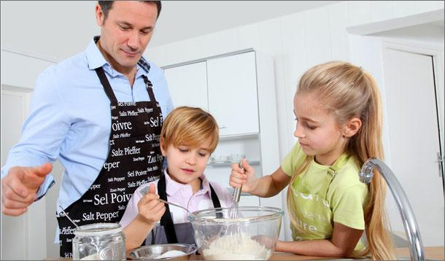
1. Two kids are helping their dad.
They are helping him mix ingredients in a bowl.
______________________________________________________________
______________________________________________________________
2. The dad is wearing an apron and the kids are wearing aprons to keep their clothes clean.
_________________________________________________________________________________________________________
3. The kids were hungry for breakfast. They wanted to make pancakes. They asked their dad
to make some. ________________________________________________________________________________________
_________________________________________________________________________________________________________
4. On Saturday mornings, they like to make breakfast with their dad and they usually make
eggs and toast sometimes they make pancakes or waffles.
________________________________________________________________________________________________________
_________________________________________________________________________________________________________
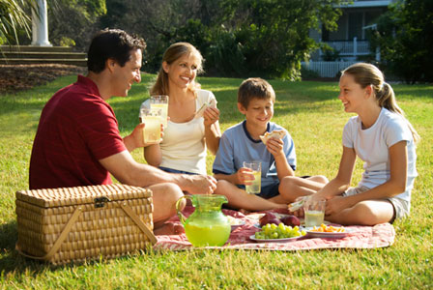
Part 3: Use these verbs to write 5 sentences about this picture. Any verb tense is ok.

have drink eat be like
smile bring talk play relax

1. ___________________________________________________________________________
2. ___________________________________________________________________________
3. ___________________________________________________________________________
4. ___________________________________________________________________________
5. ___________________________________________________________________________

Part 4: Where is this woman? What can you do here?
_______________________________________________________________________________________________________________________________________________________________________________________________________________________________________
_____________________________________________________________________________

