Writing 1
Teacher: Adam Kieffer hubbsadam@gmail.com 651 744 7578
Class webpage: hubbswriting1.weebly.com This class is Monday to Thursday.
Focus: Students in Writing 1 will practice using the simple present, present continuous, simple past and simple future tenses. The class will also focus on typing and basic computer skills, basic grammar and overall skills to making complete and easy to understand sentences.

Expectations:
- Try to attend class every day, on-time.
- If you cannot come to class, please leave me a message by phone or email. The Hubbs Center’s policy requires that you have attendance each month of 60%. If you cannot attend class this often, you may be dropped from the class.
- Please turn your cell phone to vibrate when you enter class. Please get up and go into the hallway if you need to speak on the phone during class.
- Come to class prepared to study and learn. Please bring a pencil, eraser, notebook and a folder or binder.
- You can drink in class, but no food in class. Please keep the lids on / closed on your drinks and bottles. You can eat in the student lounge.

Advancing to Writing 2:
*Students will be assessed with a monthly benchmark test and must be able to do the following on this test:
- Write complete sentences that can be understood
- Write complete answers to questions
- Use capital letters, periods, and basic punctuation correctly
- Have few spelling errors
- Correctly use the simple present, present continuous, simple past, and simple future tenses
- Have proper agreement between subject and verb
Students are also required to get a 4.0+ on the TABE E Language, or 3.5+ on the TABE M.

*We will have writing assessments (tests) at the beginning and end of each month.
Students must have basic typing skills: typing.com/student/login
You can work online anytime/anywhere: ple.platoweb.com

typing.com/student/login
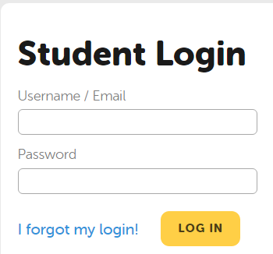

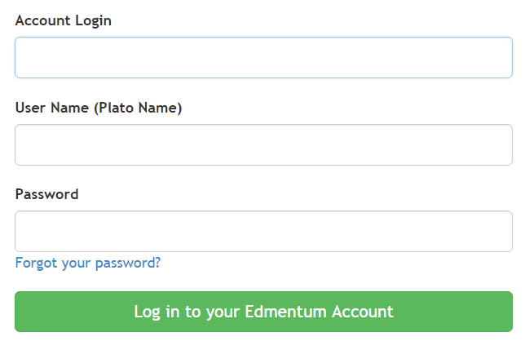ple.platoweb.com

mlc1

