Name: ___________________________
Writing 1 Benchmark September Practice
Part 1: Write a complete sentence to answer each of the five questions.

- Why is this woman raising her hand?
________________________________________________________________________
- Did she dress well or dress poorly for school?
________________________________________________________________________
- Does she enjoy or dislike participating in class? ______________________________
___________________________________
- How much time does she spend at school each day?
________________________________________________________________________
- What time do you think this student will go to bed tonight?
________________________________________________________________________

- Why do you think she is learning?
__________________________________________________________________________________________________________________

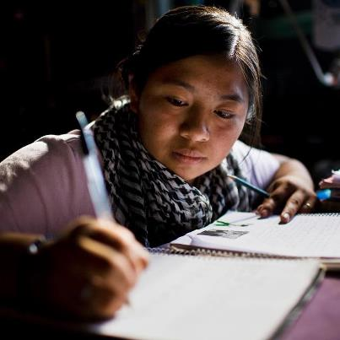
Part 2: Use the picture above to complete the sentences below. You may want to use the following actions to finish your sentences: take notes; write in her notebook; do her homework; attend school; get ready for school; practice her writing skills; take a test; return home; wear glasses; work with another student; eat dinner.

1. Right now ___________________________
______________________________________
______________________________________
2. Earlier today _________________________
______________________________________
______________________________________
- 3. She usually __________________________
- ______________________________________
- ______________________________________
- 4. In a few moments,_____________________ ______________________________________
- ______________________________________
5. This woman isn’t _____________________ ______________________________________
______________________________________
6. After school__________________________ ______________________________________
______________________________________

