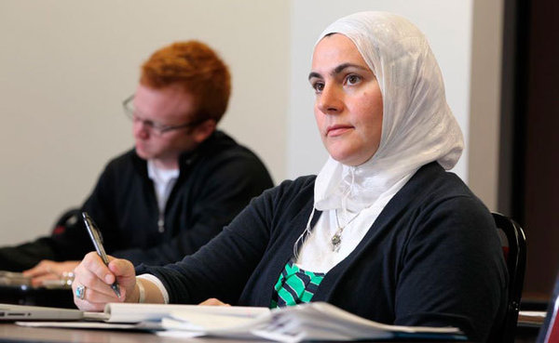
Writing 1 September Benchmark Test Name: ________________________
Marian
Part 1: Answer the questions with complete sentences.
- Where is Marian? __________________________
______________________________________________
- What is Marian doing? _____________________
______________________________________________
- Why did Marian come to this place?
____________________________________________________________________________
- What will Marian do later?
____________________________________________________________________________
- How long is Marian usually here?
____________________________________________________________________________
6. What class do you think Marian is in?
____________________________________________________________________________

Part 2: Put the correct verb in these sentences. You may need to change the verb tense.
do be want have know take hope
Vang Thao _______ many goals. First, he ____________ to improve his computer skills so he can use the internet and __________ better care of his laptop. Second, he needs to improve his English speaking and writing skills so he can ________ a better business man. Finally, he wants to take a business management course at St. Paul College. He ___________ this _______ a long-term goal, but he’ll do his best to achieve it. It probably ___________ him several years, but he _____________ to get a two year degree from St. Paul College.

Part 3: Write 5 or more sentences about this picture.
Use 4 verbs tenses (past, present, present continuous, future)

