Private boat owners come to the rescue after Hurricane Harvey
By Rory Carroll, The Guardian, adapted by Newsela staff
09/04/2017
Word Count 520
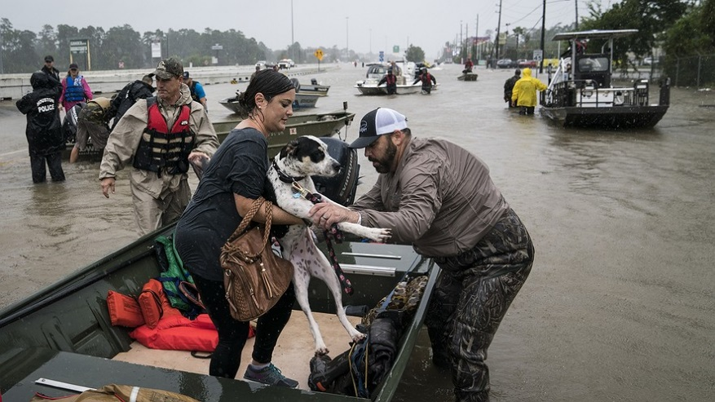
John Brown brought his 16-foot fishing boat. Dale Montalban brought his wetsuit. Cassandra Luna brought a life vest. Last week, these three people showed up in Houston, Texas. They were there to help out. A huge hurricane named Harvey had hit the area, causing flooding and other damage.
Harvey was the biggest hurricane to hit the U.S. in more than 10 years. Hurricanes are giant storms. They hit coastal areas near the ocean. They have fierce winds. They also often cause the oceans to rise. This can create flooding.

Houston Volunteers Offer What They Can To Help
In Houston, Brown, Montalban and Luna went to work. Brown drove his boat through the flooded streets. He picked up people and delivered them to safety. Wearing his wetsuit, Montalban helped people get into boats. He carried their belongings for them. Luna offered people her life vest. She had just bought it. They were not the only volunteers. Many, many more helpers spread out across the Houston area. They promised to stay and help all week.

Americans Coming Together
No one sent them. No one was paying them. They came to help people they had never met. “I think it’s beautiful, everybody coming together to do this,” said Brown. He was looking at a terrible scene. Flood waters rushed through Woodlands, Texas, a town just north of Houston. Hundreds of families were trapped in their homes. Tree-lined streets were turned into waist-high rivers.
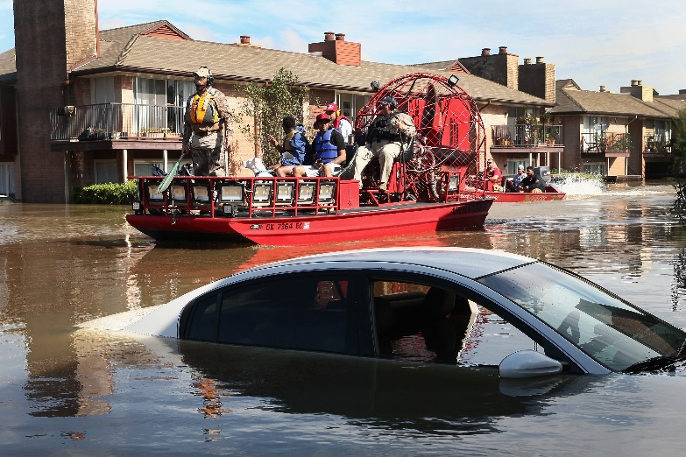
Brown's own town 30 miles away had some flooded areas. Still, he went to Woodlands with his boat because he wanted to help. Montalban felt the same way. He helped families and their pets get to dry land. Then vehicles picked them up and took them to shelters. Luna turned up with an orange life vest. It still had the price tag on it. “I was imagining there wasn’t going to be any help," she said. "But there are so many people here.”

Boats Ferry Harvey Victims To Dry Shelter
“Why do I do this?” Brown wondered, as he drove his boat past some fallen trees. “Well, why not?” He had picked up more than 50 people by early afternoon and planned to continue until after dark.
One boat returned with an elderly couple, while another arrived loaded with dogs. A man used an inflatable pool to carry food and supplies to safe, dry places.
A woman named Claire Torres climbed out of a rescue boat, holding her baby in her arms. “It’s all good," she said. "We have a place to stay.”
People worked all across the city of Woodlands, offering a helping hand. At one point a family in a black SUV got stuck in a downpour of rain. They might have been swept away. Luckily, they were rescued by Nick and Jeremy Hicks, two brothers who own a tow-truck business.
Would the Hicks brothers be doing any more rescues?
“You bet," Nick said. "It feels good.”

