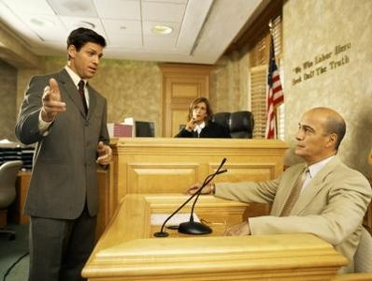
Writing 2 May Benchmark Practice Test
Susan- judge
Fred-prosecutor
Name:

Tom-defendant

Part 1: Write complete sentences to answer the questions below.
1. What is Susan’s job?
_____________________________________________________________________________
2. What crime did Tom commit? (Vandalism?, Murder?, Burglary? Littering?)
_____________________________________________________________________________
3. What is Fred doing right now?
_____________________________________________________________________________
4. Does Tom feel happy to be in court?
_____________________________________________________________________________
5. Do you think the jury will decide that Tom is guilty or innocent?
_____________________________________________________________________________
6. Are Tom and Fred co-workers?
_____________________________________________________________________________
7. Have you ever been in court? If, yes, why?
_____________________________________________________________________________

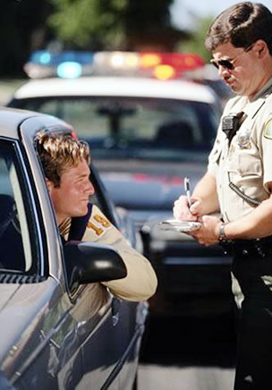
Part 2: Use the verbs below to complete the sentences. Remember to change the verb to the correct verb tense as needed.
Jamie
give pay commit drive stop (not) be try
1. Usually, Jamie _____________________ very carefully.
2. Unfortunately, Jamie ____________________ a traffic violation a few moments ago. He _______________________ at a stop sign.
3. Right now, a police officer ____________________ Jamie a ticket.

4. Jamie’s crime __________ not a felony. It _________ just a violation.
5. In a couple days, Jamie ____________________ the fine online with his credit card.
6. Jamie ________________ to remember to slow down this week.
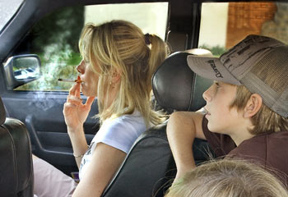
Part 3: Look at this picture. What is happening?
Is this legal? How does it make you feel?
Write 5 or more sentences about this picture.

________________________________________________________________________________________________________________________________________________________________________________________________________________________________________________________________________________________________________________________________________________________________________________________________________________________________________________________________________________________________________________________________________________________________________________________________________________________________________
_____________________________________________________________________________

