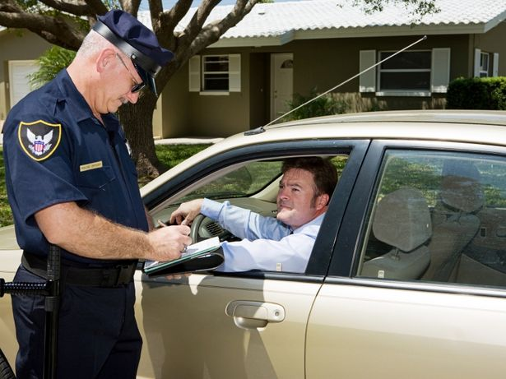
Writing 2 Benchmark May Name: _____________________________
Part 1: Complete the paragraph below using the information you see in the picture. Use these verbs to complete the paragraph:

give a speeding ticket go be turn
pull over be in a rush tell look
drive more carefully hear want (negative)

Usually, Victor __________ a very careful driver. However, he ________________________ to
get to work on time yesterday morning, so he drove faster than normal. Unfortunately, he _________ over the speed limit. The speed limit ________ 45 miles per hour, but Victor was driving 60 miles per hour! Suddenly, Victor _______________ the sound of a police siren. He _________________ in his rearview mirror and saw that there was a police car behind him. Immediately, Victor __________________ to the side of the road and _______________ off his car engine. Officer
Martinez parked his car behind Victor's car, and then he __________________________________ to Victor. In this photo, Officer Martinez ______________________Victor that he broke the law. In the future, Victor ________________________________________ because he _____________________
to receive any more expensive traffic tickets for speeding.
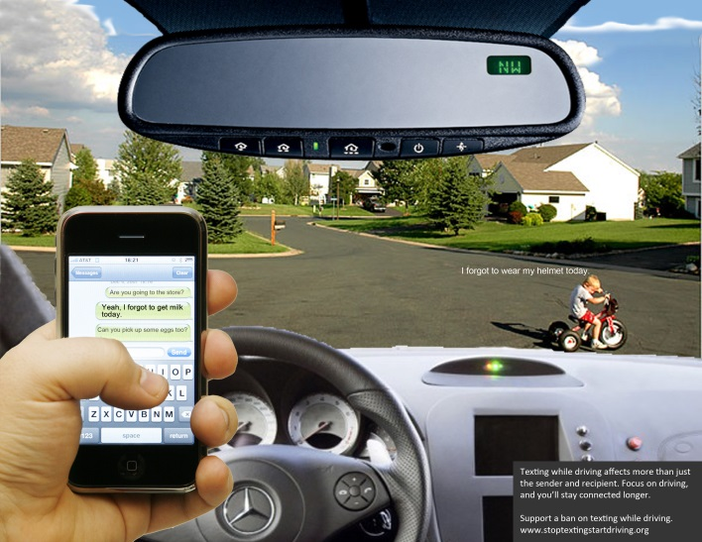
Part 2: What’s happening in the picture?
What could happen? Write 3-5 sentences.

_______________________________________________
_______________________________________________
_______________________________________________
_______________________________________________
_______________________________________________
_______________________________________________
_________________________________________________________________________________
_________________________________________________________________________________
_________________________________________________________________________________

Part 3: What is happening in this picture? What would you do, if you saw this happening?
______________________________________________________________________________________________________________________________________________________________________________________________________________________________________________________________________________________________________________________________________________________________________________________________________________________________________________________________________________
Part 4: Change all the present tense verbs to the present perfect tense.
The Montoyas’ Problem
Bertha Montoya, her husband and three children live in a dangerous part of town. They are afraid to go out at night because there are so many robberies and other crimes in their neighborhood. They don’t have enough money to move to a safer neighborhood.
From her kitchen window, Bertha sees people and cars that come and go. On Saturday night, Bertha saw a man selling something in the alley behind her apartment. Her teenage son tells her that the man is selling drugs. Bertha’s husband is at work. Bertha calls the police, but they don’t come for a long time, and the people in the alley are gone when the police arrived.

