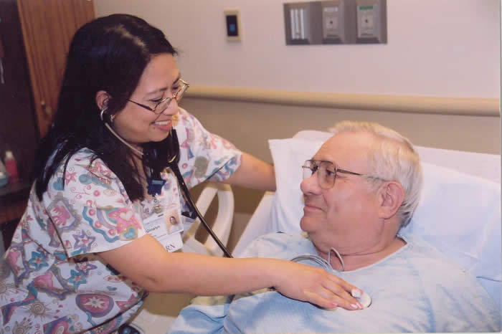
BE: am / is / are / was / were / will be DO: do / does / doing / did / will do
HAVE: has / have / having / had / will have

Correct the BE, DO and HAVE verbs in this story.
Mary be a nurse a Regions Hospital. She do a great job taking care of patients. She usually have between 8 and 15 patients that she have to take care of during her 10 hour shift. Mary’s work schedule do 4 days on, three days off.
In this picture, Mary has listening to the patient’s heartbeat, or his pulse. She having to use a stethoscope for that. This patient, John, did a heart attack last night. He was chest pain and difficulty breathing. His wife will be worried, so she called 911. The operator asked, “Do he breathing? Do he have chest pain?” His wife said, “Yes!” The operator said, “The ambulance and paramedics will being there in about 15 minutes.” She were very scared. The paramedics arrived, checked John, and told her, “He will has to go to the hospital for some tests and to be safe.”
Today, John do on some medication and resting. The staff will did their best to determine the best treatment for John. He will doing in the hospital for another day. John don’t want to have a heart attack again. He is very scared yesterday. He will doing his best to follow the doctor’s plans for him.
Does you know a nurse or a doctor? Am they a man or a woman? Do you ever has to go to a hospital? What was you there for? How doing the doctors and nurses care for you? Does you usually take your kids for a yearly physical? Am you healthy? Does you eat healthy and exercise?

