House and Yard Quiz
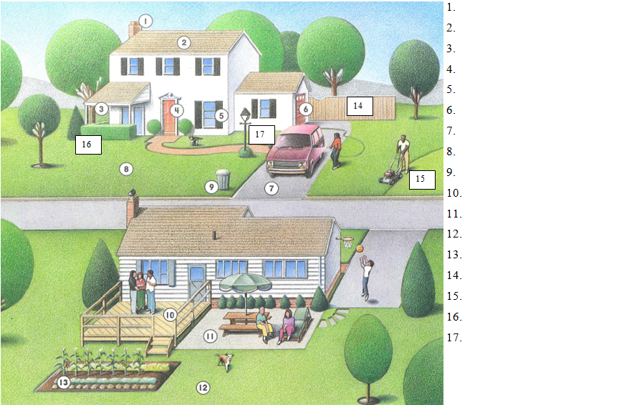

House and Yard Quiz

House and Yard Quiz Part 2
1. The __________________ is where smoke or gas comes of out the top of a house.
2. The top of a building is called the ______________.
3. The _____________ is where you can relax outside, but still be under the house or roof.
4. The _________________ is where you people can come in and out of a house.
5. A ________________ lets light in. You can cover it with curtain, blinds, or shades on the inside.
6. The _______________ is where you park your car or store tools, bikes, supplies, and anything else you have.
7. The ________________ is where you can park your car, or your kids can play and ride their bikes.
8. The _________________ is where the grass grows and kids can play.
9. You put the _____________________ or the curb once a week to the garbage truck will empty it.
10. A _______________ is made of wood, and it’s a nice place to hang out, talk, and eat.
11. A _________________ is made of cement or stone blocks and is also a nice place to hang out, talk, and eat.
12. Kids love to play behind the house in the _______________________. Many people have gardens there too.
13. You can plant herbs, flowers, and vegetables in a _____________________.
14. A __________________ is nice for privacy, to keep dogs out, and to keep kids safe.
15. You can see many people using a _________________________ to cut their grass on the weekends.
16. _________________ are usually tall green bushes that people use like a fence.
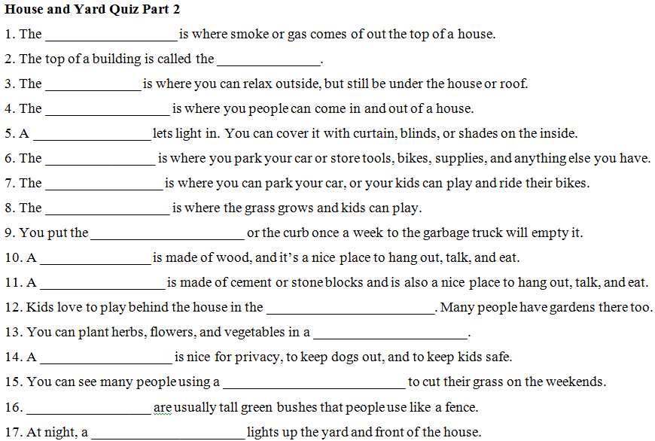
17. At night, a _____________________ lights up the yard and front of the house.

