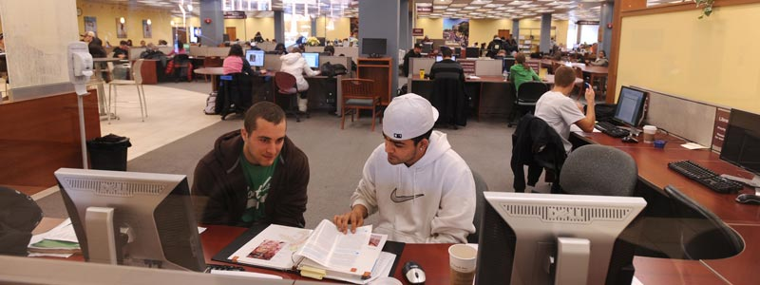
Write about this picture for 15-20 minutes. What do you see? What is happening?
What happened earlier? What will happen next? What usually happens here?

