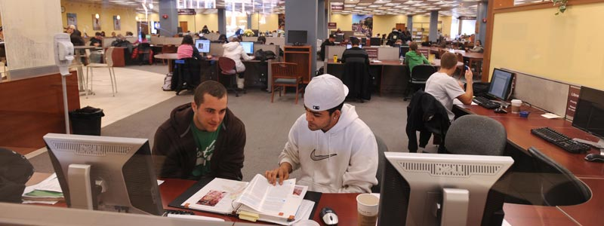
Computer Lab: Correct these sentences.
1. They are computer lap.

2. I think one of the students having a toter.

3. There are student in computer lap.

4. Next they will working together and helping eachother.

5. All of them they are students.

6. One of them he is wearing a white Hat.

7. The classroom have a lot stuff.

8. I see the poeble they are working on home work.

