Combine these sentences.
Lisa and Tim
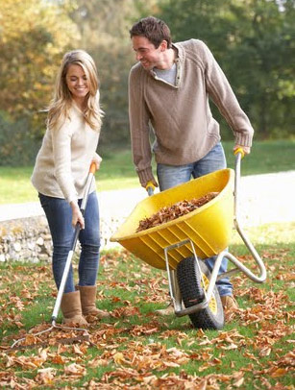
1. Lisa is working in the yard.
Tim is working in the yard.
__________________________________________________________________________________

2. Tim is wearing work boots.
Lisa is wearing winter boots.
__________________________________________________________________________________

3. They are raking leaves. They will dump the leaves in a pile. They will bag the leaves.
__________________________________________________________________________________

4. The like to do yard work on the weekend. They like to go to the park on the weekend.
They also enjoy riding their bikes around the lake on the weekend.
__________________________________________________________________________________________________________________________________________________________
5. When they’re done working, they take a shower. They change their clothes. They cook dinner and maybe watch a movie.
__________________________________________________________________________________________________________________________________________________________

6. On Sunday, Tim wants to see a movie. On Sunday, Lisa wants to go to a bookstore instead.
____________________________________________________________________________

7. They don’t agree on the same thing to do. They call some friends to come over to play games. _______________________________________________________________________
_____________________________________________________________________________

