Combine the sentences or break up run-on sentences.
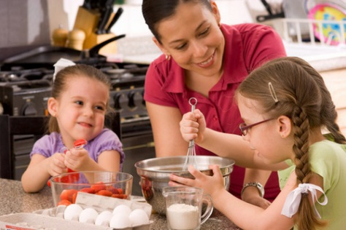
1. Two girls are helping their mom.
They are helping her mix ingredients in a bowl.
______________________________________________________________
______________________________________________________________
2. The mom cracked an egg and her daughter cracked an egg and put them in the bowl.
_______________________________________________________________________________________________________
3. The kids were hungry for dinner. They wanted to make French toast. They asked their
mom to make some. ________________________________________________________________________________
________________________________________________________________________________________________________
4. On Saturday mornings, they like to make breakfast with their mom and they usually make
eggs and toast and sometimes they make pancakes or waffles.
________________________________________________________________________________________________________
________________________________________________________________________________________________________

Combine the sentences or break up run-on sentences.
1. Two girls are helping their mom.
They are helping her mix ingredients in a bowl.
______________________________________________________________
______________________________________________________________
2. The mom cracked an egg and her daughter cracked an egg and put them in the bowl.
_______________________________________________________________________________________________________
3. The kids were hungry for dinner. They wanted to make French toast. They asked their
mom to make some. ________________________________________________________________________________
________________________________________________________________________________________________________
4. On Saturday mornings, they like to make breakfast with their mom and they usually make
eggs and toast and sometimes they make pancakes or waffles.
________________________________________________________________________________________________________
________________________________________________________________________________________________________

