They make it look easy but it's not: ballerinas deal with serious foot pain
By Washington Post, adapted by Newsela staff 06.02.17
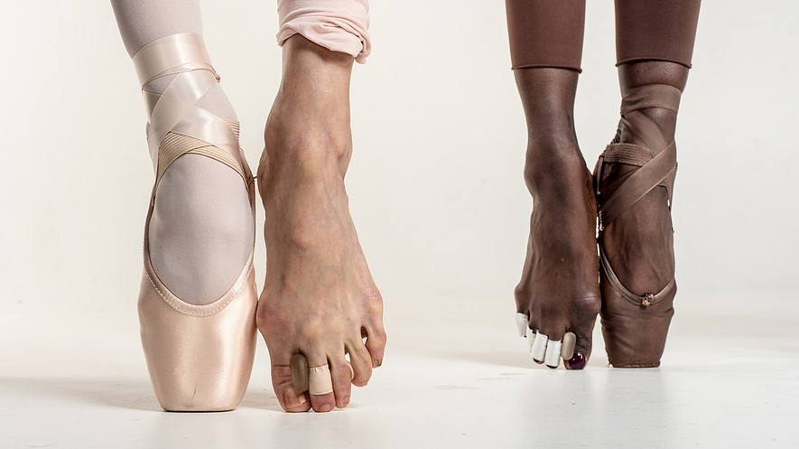
Sona Kharatian and Ashley Murphy, whose feet are shown above, are company dancers at the Washington Ballet. Dancing takes a huge toll on the feet, and elite and professional dancers have dedication and grit that is above and beyond that of the average person. Photo by: Andre Chung for The Washington Post
Lauren Lovette is a professional ballerina. She is a lead dancer with the New York City Ballet. Like many dancers, her feet are often hurting. "I feel like I'm always in a battle with my feet," says Lovette, with a sigh. She has injured them many times. She had an operation to fix a bone problem. But even with daily ankle exercises and many ice baths, Lovette has not made peace with her feet.
Dancers run, jump, squat and leap like any basketball star. Basketball players do it with comfortable shoes. In fact, most athletes get to wear shoes that protect their feet. Not dancers, though.
They Make It Look So Easy
Dancers may speed around the stage barefoot. Sometimes they wear shoes with high heels. If they're ballerinas, they wear tight-fitting pointe shoes in order to get all the way up on the tips of their toes. Pointe shoes may look delicate. Ballerinas make getting on their toes look easy. However, when they dance in pointe shoes, ballerinas are doing what few humans can.
"Dancers are just as strong as football players, if not stronger," says Lisa M. Schoene. She's a Chicago foot doctor who treats dancers. Ballerinas must balance all of their weight on the tiniest tips of their toes. This is called dancing "en pointe." Dancers have to be incredibly strong in order to do it. "Getting up on pointe is one of the most athletic things you can do," Schoene says.
The Very First Pointe Shoes
Before 1832, dancers didn't often get up high on their tiptoes. That year, Italian ballerina Marie Taglioni wore a type of homemade pointe shoes in a show. As she stood up high on the tips of her toes, she seemed to be floating. Other dancers copied her moves, and this became a popular trick. Shoemakers started making the insides of ballet slippers hard and stiff. They put in layers of fabric and glue.
Pointe shoes are still made that way today. The shoe and the foot must work together as one, so each dancer must make their shoe fit perfectly. Even the most famous ballerinas sew on their own ankle ribbons and elastics to secure the shoes. Some ballerinas have to sew and break in new shoes almost every day. A pair of pointe shoes costs around $100, but it may last a pro just one day.
Breaking In A New Pair
Each ballerina has her own special way of breaking in new shoes. Claire Kretzschmar is a member of the New York City Ballet. She lays her new shoes on the ground and stomps on them. After that, she pours quick-drying glue on the tips to make them hard. To protect her toes, she wraps them in a brown paper towel. Lovette bangs her shoes against a wall about 20 times to get rid of clunkiness. If shoes are clunky and loud, they can make a loud clop-clop sound on the dance floor. It can ruin a ballet show.
Fear Of Being Forgotten
Ballet dancers are frequently competing to be in the best shows. Their feet do not get much rest. Ballet dancers often dance through pain, says foot doctor Stephen Pribut. Kretzschmar has had a few broken bones. Lovette has amazing foot flexibility, but faced much pain in her early years at the New York City Ballet. It turned out she had an extra bone in her left foot. She didn't get it fixed until six years later.
After that last performance before the operation, "walking out of the theater was scary," Lovette says. "What if I'm forgotten about? That's always a dancer's fear." That was two years ago. After months of rest, she returned to the stage, her foot problems behind her. Then, she started having problems with her other foot.
How a ballerina treats her feet every day is important, Pribut says. And it's true for any of us. Our footwear is an important tool no matter what we do. Some shoes can cause more stress than pointe shoes if they're worn too often, the doctor adds. Flip-flops, high heels and ballet flats are all bad for our feet.
Quiz
- What is the MAIN idea of the section "They Make It Look So Easy"?
A: Ballerinas must be incredibly strong.
B: Some dancers perform onstage barefoot.
C: Pointe shoes look pretty and delicate.

- Which two of the following are MAIN ideas of the article?
A: Ballerinas do ankle exercises and foot baths to help their feet.
B: Ballerinas' feet often suffer pain and injury from dancing.
C: Ballerinas use special pointe shoes that are molded to their feet.
D: Ballerinas sometimes worry that clunky shoes will ruin a show.

- Read the section "The Very First Pointe Shoes." Which sentence shows WHY a ballerina's pointe shoes are important?
A: Shoemakers started making the insides of ballet slippers hard and stiff.
B: The shoe and the foot must work together as one, so each dancer must make their shoe fit perfectly.
C: Even the most famous ballerinas sew on their own ankle ribbons and elastics to secure the shoes.
- Read the paragraph from the section "Fear Of Being Forgotten."
“Ballet dancers are frequently competing to be in the best shows. Their feet do not get much rest. Ballet dancers often dance through pain, says foot doctor Stephen Pribut. Kretzschmar has had a few broken bones. Lovette has amazing foot flexibility, but faced much pain in her early years at the New York City Ballet. It turned out she had an extra bone in her left foot. She didn't get it fixed until six years later.”
Which sentence from the paragraph BEST supports the conclusion that ballerinas sometimes wait a long time before getting help for problems with their feet?
A: Ballet dancers are frequently competing to be in the best shows.
B: Ballet dancers often dance through pain, says foot doctor Stephen Pribut.
C: Kretzschmar has had a few broken bones.
D: She didn't get it fixed until six years later.

This story has 5 sections. Write a summary of this story that includes at least one sentence from each section.
____________________________________________________________________________________________________________________________________________________________________________________
____________________________________________________________________________________________________________________________________________________________________________________
______________________________________________________________________________________________________________________________________________________________________________________________________________________________________________________________________________
______________________________________________________________________________________________________________________________________________________________________________________________________________________________________________________________________________

