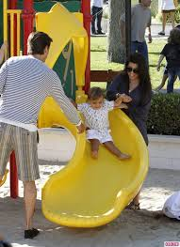
April Practice Assessment Writing 1 Name: ______________________________

Joe
Marie

Oscar

Part 1: Answer the questions with complete sentences. Pay attention to the verb tense.
1. When did this family go to the playground?
____________________________________________________________________________
2. Do you think Oscar enjoys spending time with his parents?
____________________________________________________________________________
3. How many times do you think Oscar will go down the slide?
____________________________________________________________________________
4. In this photo, what is Marie doing?
____________________________________________________________________________
5. Do you think this playground is clean or dirty?
____________________________________________________________________________
6. Did you go to the park when you were a child?
____________________________________________________________________________

April Practice Assessment Writing 1

Ling Amy

Part 2: Fill in the blanks with these verbs. Change the verb tense to match the sentence.
mail go feel enjoy withdraw walk want work deposit buy be
1. Amy and Ling __________________ in a busy city.
2. Amy and her friend, Ling, ___________________ to the post office a short time ago.
2. While they were at the post office, Amy ______________ some letters, and Ling _________________ some stamps.
3. At this moment, they ____________________________ to the bank.
4. In a few minutes, Amy ________________________ her paycheck, and Ling
________________________ some cash from the ATM.
5. They _____________ to take the bus back to their office because Ling _______________ tired.
6. Amy and Ling _______________ spending time together during their lunch break every day.
7. They ________________ so busy, they forgot to eat lunch!

