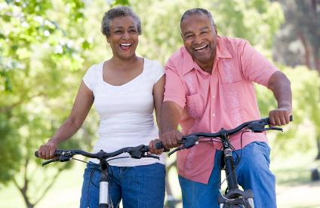
Ellen and Herb enjoy riding their bikes together in the spring, summer, and fall. On warm days, they love to go bike riding together for about an hour. Usually they ride their bikes on bike trails in their community. Sometimes they bike to the grocery store or to the bank. Biking is an activity they both enjoy because it gives them a lot of exercise and time to talk with each other. They began biking together after they got married almost 25 years ago, and they hope to continue biking together for many years to come. They know that keeping active is a good way to stay healthy as they get older.
Next weekend, if the weather is nice, they are going to bike along the Mississippi River in St. Paul. It’s almost 20 miles round trip, but they plan to take their time and stop for a picnic lunch.
Answer the following questions with complete sentences.
1. When did they get married? _____________________________________________________________
2. Does this couple like to go biking in the winter? _____________________________________________
3. Where do Herb and Ellen usually ride their bikes?
_______________________________________________________________________________________
4. Are they going to bike to Wisconsin next weekend? __________________________________________
5. Why do Ellen and Herb enjoy biking?
_______________________________________________________________________________________
6. Do you think they have a good relationship? Why or why not?
_______________________________________________________________________________________
7. What activity do you like to do with your spouse, children, or friend?
______________________________________________________________________________________
8. Write a short summary of this story.
____________________________________________________________________________________________________________________________________________________________________________________________________________________________________________________________________________________________________________________________________________________________

